China Knowledge Addresses the CAC in Beijing, August 29, 2015

China Knowledge Addresses Key Points of Interest of China Administration of Cybersecurity
• • •
- Cyber Security Course Design in American universities;
- CAE in scientific research and talent training;
- Two years’ college IA training programs
- Cyber Security related training and certification system in USA;
- Allocation of positions and skill requires of American Cyber Security human resources.
- Chen Xing Shu
Network and Trusted Computing Institute, Computer College of Sichuan University, http://ntci.scu.edu.cn

China Knowledge | 9/23/2015 | EDITION 2, VOLUME 1

  - Advancing Cause of Secure International Cyber Space

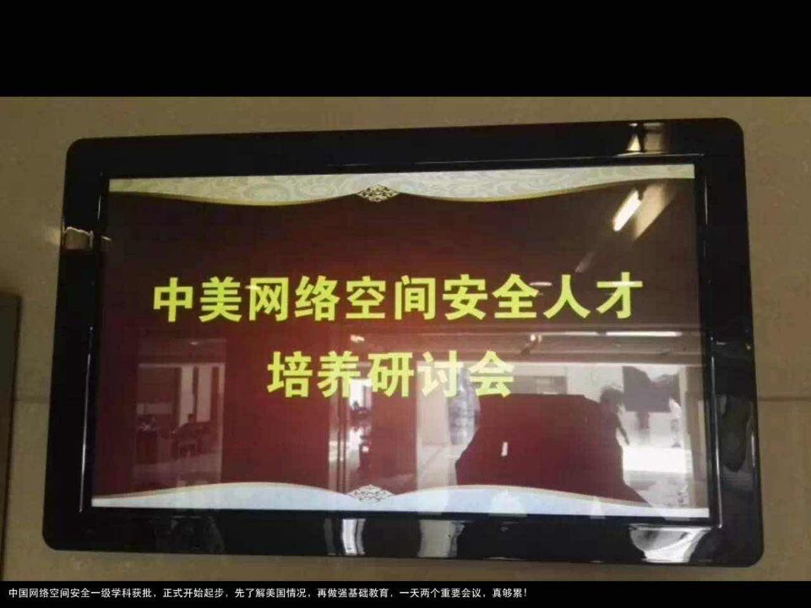
On August 29, 2015, a groundbreaking meeting, attended by China Knowledge and sponsored by the China Administration of Cybersecurity, was held in Beijing. “We sincerely believe that our “Three Pillars” strategy will find an important and lasting place in the realms of IA and Cyber Security in China”
-Mr. Hank Wang, CEO, China Knowledge

East Meets West over Cyber Space:
China Knowledge addresses the China Administration of Cybersecurity

The morning was fresh and cool as core members of the China Knowledge leadership team mingled over a friendly breakfast with members and associates of the CAC (China Administration of Cybersecurity) in Beijing.
Cards were exchanged and informal introductions made before the attendees (attachment below) were seated and the meeting was formally brought to order.
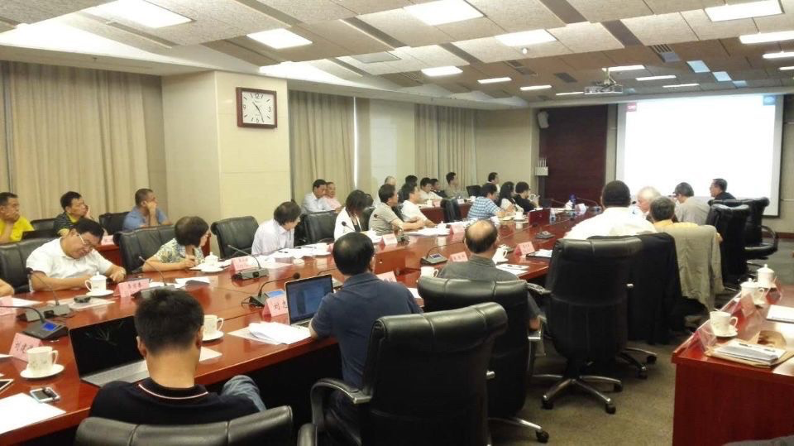
The key speakers from China Knowledge (Hank Wang, Dr. Ernest L. McDuffie, Henry Chang and Dr. James Quinlan) utilized a slide presentation to address Professor Chen’s key points (above) in greater detail. Beyond this, the CK Team went on to provide appropriate detail regarding its “Three Pillars” model.
The Three Pillars model to initiate, integrate and move Cyber Security forward in China.
How will China move forward to realize its clearly stated national policy to address its expanding matrix of unmet national & international cybersecurity issues? How can China and the other national players on the world stage find and develop common ground on the challenges of maintaining cyber-sovereignty and Internet control? From within its diverse political, economic and social systems, how will China balance its national security interests in a unified manner that protects local & global cyber infrastructure? China Knowledge will address what is an uneven and somewhat fragmented landscape of Chinese cyber policies & initiatives with proven, cohesive, comprehensive and highly pragmatic modules. China Knowledge has identified three key pillars (Enterprise, Academia and Policy) to support and implement China’s Cybersecurity Mandate. The Three Pillars are organic to China’s culture and cyber-ecology, providing cross-linkage that informs and strengthens all sectors. By expanding, harnessing and focusing proven best practices while building upon a Center of Excellence template, China Knowledge will integrate and actualize President Xi’s national cybersecurity mandate across a tripartite foundation of: 1) Academic-initiative Programs of Training & Certification; 2) Key Enterprise Partnerships (Government, Private & SOE); Ongoing Consultancy & Advocacy (on issues national and multilateral policy).
The presentation was followed by a lively Q&A between the CK and CAC participants, after which Mr. Zhao of the CAC expressed his sincere gratitude. the participants broke into small groups for more targeted dialogue. The atmosphere was friendly, and the Chinese side had many thoughtful, insightful and challenging questions for which the China Knowledge team gave considered responses. This often bilingual task was made much easier by the excellent translator provided by the Chinese side.
(Above)Dr. Ernest L. McDuffie explains intricacies of the U.S. Academic Centers of Excellence, and National Initiative for Cybersecurity Education
China Knowledge:
Where East Meets West In Cyber Space

Dr. James Quinlan, Vice President
China Knowledge
23A Tower 2
Beijing High-Tech Convention & Exhibition Center
48 North 3rd Ring Road, West
Beijing, China 100086
jtquinlan@china-knwldg.com
+86-13261135295

This meeting gave Mr. Zhao, Head of China Administration of Cybersecurity, the opportunity to hear first-hand from U.S. experts on the challenges and lessons learned from the U.S. experience in Cyber Security training and education. The sobering fact is that even after more than a full decade of focused endeavor of CAE under the aegis of the Department of Homeland Security (DHS) and National Security Agency (NSA), the United States still lags significantly behind it purported training goals in the areas of Information Assurance and Cyber Security. In other words, after an organized and well-orchestrated national effort, the U.S. effort still lags behind the curve of its stated goals in Cyber Security Education and training. However, what has evolved in those years is what has become the international gold-standard model, despite the inherent challenges in deployment and implementation.
“What has been achieved in this field simply cannot be jump-started de novo in China: a country which presently is somewhat disjointed and fragmented in this area. However, given the proper mandate, and already in possession of an excellent, world-class team, China Knowledge (CK) is ideally positioned to work with its partners in China to implement a powerful and effective response.” –Hank Wang, CEO, CK.

